**Time and Attendance Configuration Program Step by Step Guide**

First what you need to do is go the Box Sync and create a short cut to your desktop so that you can run the program from you’re locate desktop and not open Box Sync every time. The location for the program is: ***C:\Users\<Your Local User Account>\Box Sync\Tna\Time and Attendance configuration.exe***.

Once you have done that open the program **As Administrator** and you will see the following window:

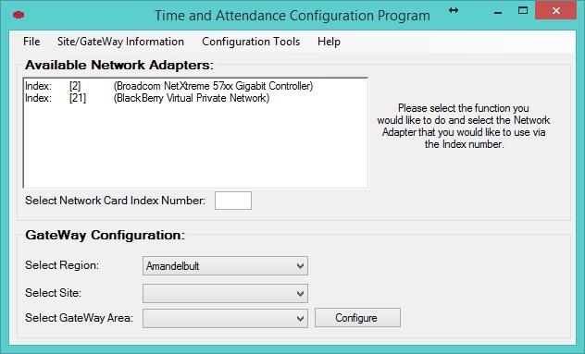

In this window you will see the following information:

* The menu bar (This is used to navigate to different programs)
* The Available Network Adapters (This is used to select you Ethernet network card)
* GateWay Configuration (This is used to configure the Time and Attendance GateWay)

**The Menu Bar**



In the Menu Bar you will see:

* File (Used for alternative Exit)
* Site/GateWay Information (Used to Add, Change, Remove and Restore Sites and GateWays)
* Configuration Tools (This Tab has all the Time and Attendance Software)
* Help (Just information about the Program)

**1. File**

The File Tab is just used for an alternative way of closing the program.

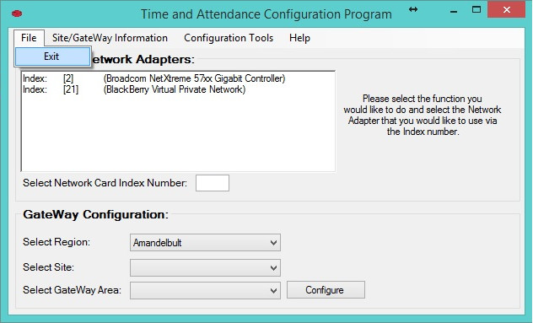

**2. Site/GateWay Information**

In this area you have 4 options:

* Add New Site/GateWay (Used to add a new Site/GateWay)
* Change GateWay Information (Used to Change the Site/GateWay)
* Remove Site/GateWay (Used to Remove the Site/GateWay configuration file)
* Restore Site/GateWay (Used to Restore the Site/GateWay configuration file)

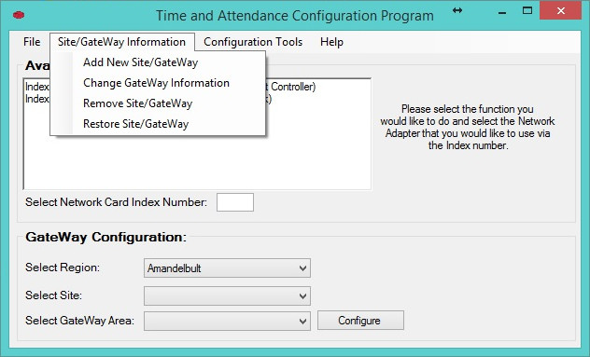

**3. Configuration Tools**

In the Configuration Tools tab you have 7 options:

* Sagem Configure (Before you can select this please select a network card index in the Main Window of the program)
* Rabbit
* Shroom
* UDPTool
* DBConnect
* LifeLoc Tester Firmware
* LC Programs (This has 2 Extra options: LC Reader Finder and LC Firmware Uploader)

All the tools in here are used by the Time and Attendance Technician.

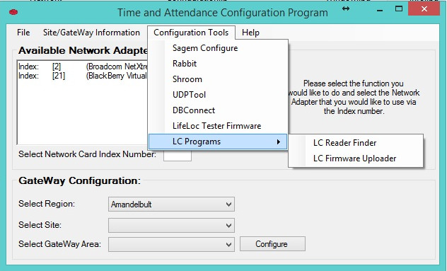

**4. Help**

In the Help tab is the About Time and Attendance Configuration Program

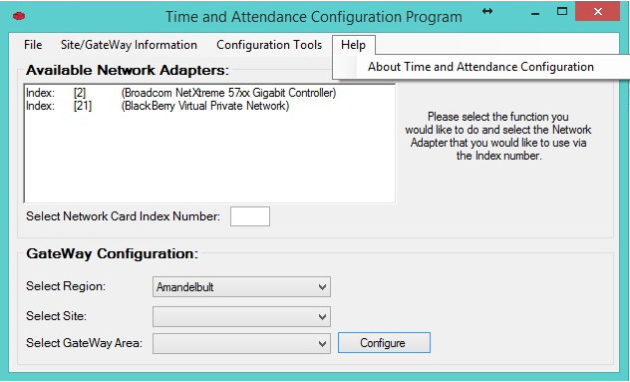

**The Available Network Adapters**

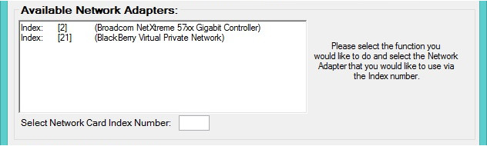

The Available Network Adapters will automatically detect all your network connections (Wi-Fi, Ethernet and Virtual). What you need to do here is select your Ethernet card the one you will be using in order to configure the GateWay and Sagem devices as shown in the example below:

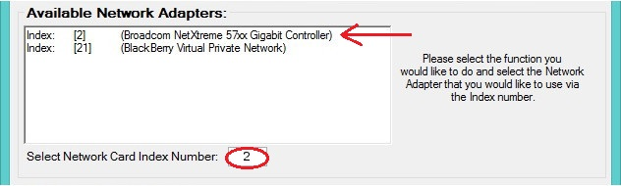

As you can see the current Ethernet card on this example is on Index [2] that means I select the index number in the opening marked with a red circle (This does not mean that your current machine also used Index [2] it will differ on other computers).

**GateWay Configuration**

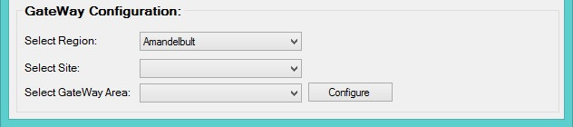

This part of the program is used to configure GateWays. All you need to do is select your network card via index as shown in the previous explanation and select your Region, Site, GateWay and then click on the Configure button (The drop down fields will auto fill when you select) this is shown in the example below:

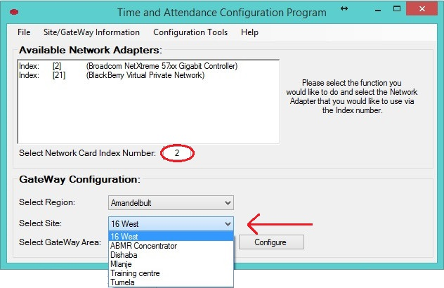

Once you have selected your required GateWay configuration file click on the configure button. This will connect to the GateWay and configure it shown in the examples below:

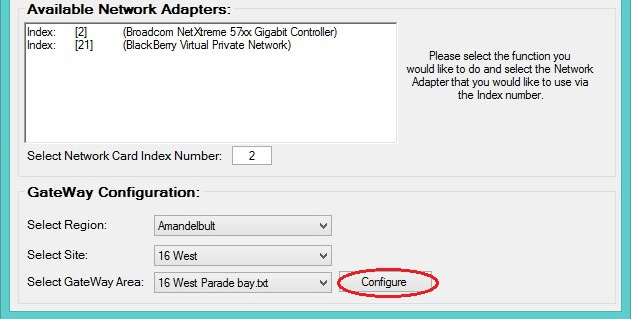

When the program has finished you will get the following message:

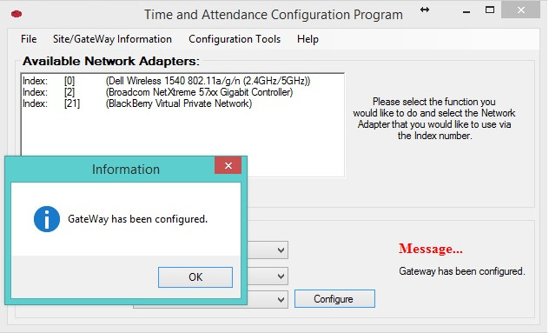

**Troubleshooting**

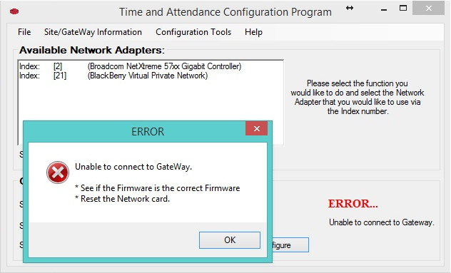

If you get the following Error message follow these simple steps:

1. Make sure you are running the program as Administrator so that the program can configure your network card and that you have selected the correct Network Card via index.
2. Make sure your Ethernet cable is plugged in properly.
3. Update the Firmware of the GateWay.
4. Reset the GateWays network card.

Once you have done that try again.

**2.1 Add New Site/GateWay**

The Add New Site/GateWay has two functions adding a Site or adding a GateWay to an existing Site.

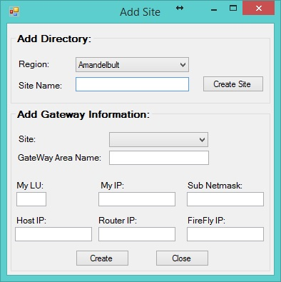

In order to add a Site just select your Region in the drop down a Fill in the Site Name the select Create Site, this will create the site in the Region selected. See example below:

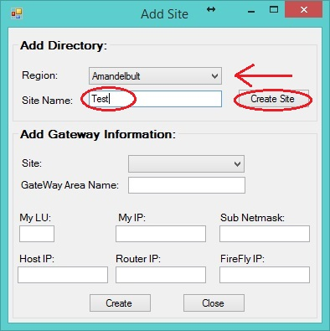

In order to add a GateWay in an existing site just select the Region, Site in the drop down menus and give the GateWay a name and filling the fields to create the configuration file. See example below:

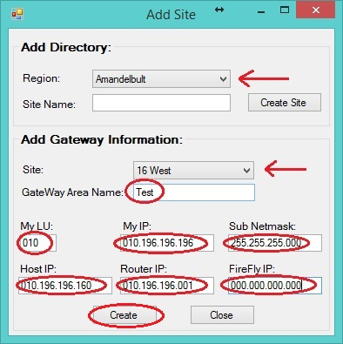

(**Note:** If you do not have a FireFly you can just put the IP as **000.000.000.000** as shown in the example above. You will have to use the full range in the IP e.g. **010.196.196.001** for the configuration file.)

**2.2 Change GateWay Information**

The Change GateWay Information is used to change the existing GateWays information.

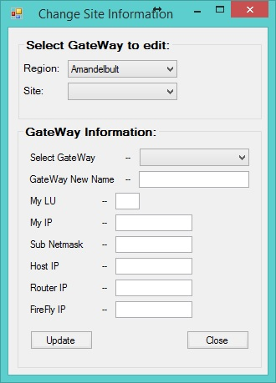

In order to do this all you need to do is select the Region, Site and GateWay, all the fields will auto fill except the GateWay New Name field this is there so that if you want to change the name of the GateWay configuration file. You will have to fill in this field, this is not a compulsory field so if you only want to change the IP addresses it will still Update the file without the GateWay New Name field. When you have made the changes to the selected file click on the Update button. See example below:

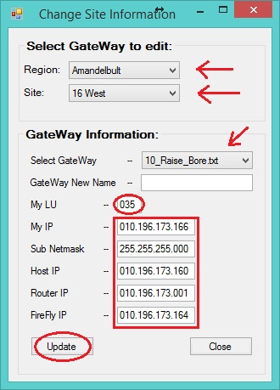

(**Note:** Remember the LU and IP addresses must be filled in the full range for the configuration to work with the program and GateWay. As shown in the example above.)

**2.3 Remove Site/GateWay**

The Remove Site/GateWay will remove the Site and GateWay configuration files so before you do anything here PLEASE make sure that you are selecting the correct Site or GateWay that you wish to remove.

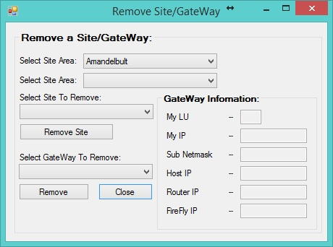

Once you have selected this tab a window will open (shown above) you have two option here Remove Site or Remove GateWay. To Remove a Site select the Region and then the Site then click on the Remove Site button. Shown in the example below: (**Note:** If you do this it will remove the site and all configuration files within this site area.)

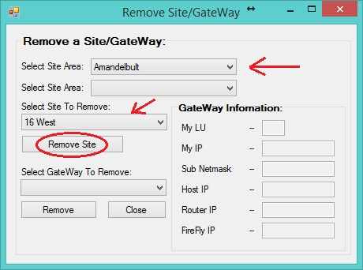

To Remove a GateWay select the Region, Site and then the GateWay you want to remove then click the Remove button. As shown in the example below:

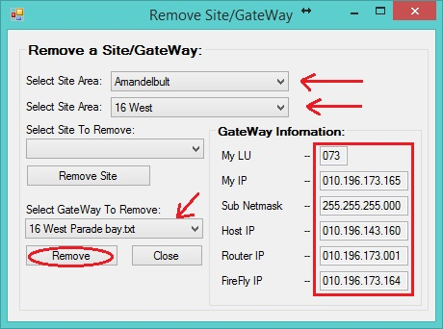

(**Note:** The GateWay will auto fill in the GateWay Information fields so that you can make sure this is the correct GateWay you want to remove.)

**2.4 Restore Site/GateWay**

The final tab in this area is the Restore Site/GateWay tab. This is used to restore a Site or GateWay that you have accidently removed.

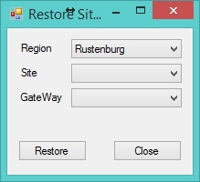

To Restore a Site select the Region and the Site then click the Restore button this will restore the whole site including all the GateWay configuration files. As Shown in the example below: (**Note:** The GateWay field is empty)

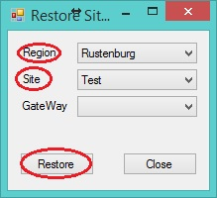

To Restore a single GateWay select the Region, Site and the GateWay you want to restore then click on the Restore button. As shown in the example below:

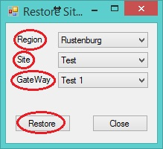

(**Note:** This will restore the files in there respectable areas)

**3.1 Sagem Configure**

In order to use the Sagem Configure tab you first need to select your network card index on the main window and then select the Sagem Configure tab. Shown below:

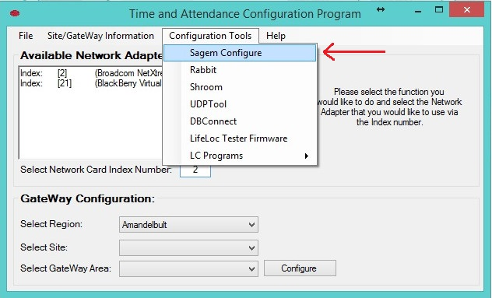

This will then open the MATM Express program so that you can upload the firmware to the Sagem Finger Reader. If it does not connect please make sure you are running the program as Administrator. Once the MATM Express program is open you can go on as normal to configure the Sagem Finger Reader.

**3.2 till 3.5 The other programs**

The programs like Rabbit, Shroom, UDPTool and DBConnect will open automatically when you select the appropriate tab for the program you want to use. Once you have selected them you can go on as normal to use these programs.

**3.6 LifeLoc Tester Firmware**

This is used to upload the firmware to a flash drive. This is used to upload the Arrow direction of the alcohol testing readers.

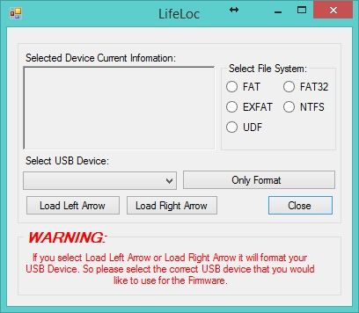

To use this first plug in your USB flash drive into the computer and then it will show you all your USB devices select the USB that you would like to use and then select the file system, then select the function you want to do for example Load the Left Arrow. This will format the drive and then load the left arrow firmware to put onto the LifeLoc alcohol testing reader. Shown below:

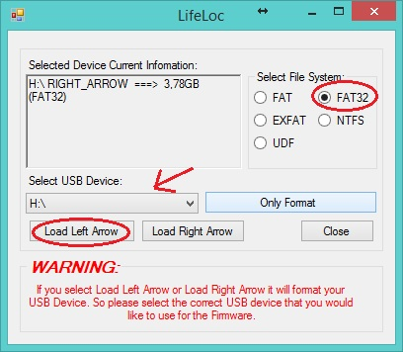

**3.7 LC Programs**

You will see that the LC Programs tab has 2 functions the first function is used to find the LC Readers IP address which will be used for the LC firmware uploader.

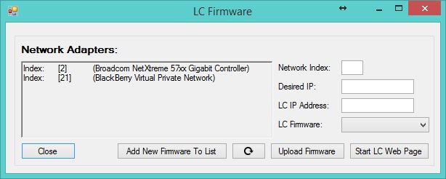

To use this what you need to do is, select your network card index as you did in the GateWay configurations (Network Index), choose an IP to use to connect to the LC (Desired IP), put in the LC IP Address that you got from the LC Reader Finder (LC IP Address), select the LC Firmware you want to upload (LC Firmware), click Upload Firmware button and then click the Start LC Web Page button to open the LC Web page so that you can upload the .bin file (this is still the old method of uploading the .bin file). Shown below:

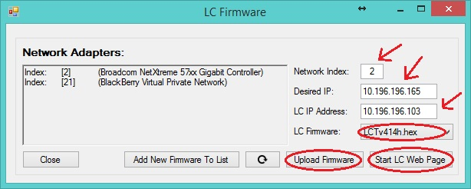

The extra button you see is to add new firmware to the drop down list of the LC Firmware. The Refresh button is used once you have added the new firmware so that it can be displayed in the drop down list if it’s not there.

To add new firmware just click on the Add New Firmware To List button and then a new window will open. Shown below:

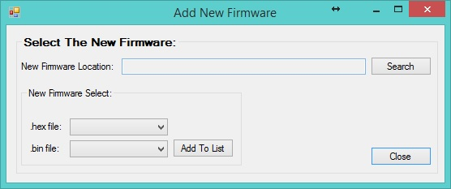

To add the firmware click the Search button and it will ask you where the files are, select the directory for the files and click OK. This will show the available .hex and .bin files to add to the list.

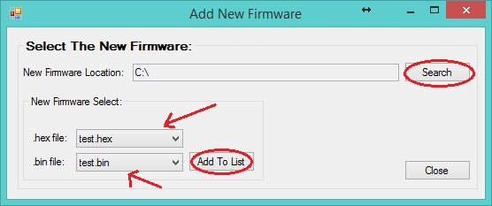

In this example the file was located in the C:\. Once you have selected the .hex and .bin file then you click the Add to List button this will add it to the list. You do not need to fill in both fields if it is not needed you can just upload the .hex file or just the .bin file. Depending on your requirements.